MATH 396

## Classifying Orbits About a Fixed Point Using Graphical Iteration

Trevor Dallow | 301263761  
April 17, 2017

Some functions can be too complex to solve analytically if we wish to determine their orbital behavior. In these cases, we may use graphical iteration to gain insight as to how a function’s orbit behaves. Graphical iteration allows us to find fixed points and figure out their respective orbital stability. In addition, this process gives us the ability to determine the stable and unstable sets of these orbits. This paper will examine the octant decomposition about a fixed point and attempt to classify all cases unambiguously. It will be seen that octant decomposition is insufficient to do so and an alternative decomposition is examined.

First, we will cover the process of graphical iteration. The diagram is centered on a fixed-point p, more precisely where a function, namely f, intersects y = x (f(x) = x). From there we select a point x0 as our starting point and evaluate f on x0, x1 = f(x0); we now have the first point on the graph (x0, x1). To find the next point x2 = f(x1) in the orbit, we move horizontally toward y = x (the point (x1, x1)) and then again vertically towards f, arriving at the point (x1, x2). We may continue this process until we can determine the behavior of the orbit, be it that the orbit approaches the fixed-point p or otherwise.

To obtain an octant decomposition, we will use vertical, and horizontal lines as well as the lines y = x and y = -x (the antidiagonal line), all intersecting at the fixed-point p. We will label each of the sections ‘a’ through ‘h’.

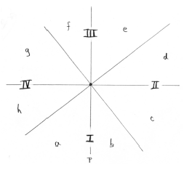

This decomposition yields a total of 16 different cases, as will be seen, 14 of these cases can be classified unambiguously, meaning that for each case, an arbitrary function may be used while still maintaining the same orbital behavior.

**Unambiguously Classified Cases Using Octant Decomposition**

a: m > 1; staircase out from p

b: m < -1; spiral out from p

c: -1 < m < 0; staircase into p

d: 0 < m < 1; staircase into p

e: m > 1; staircase out from p

f: m < -1; spiral out from p

g: -1 < m < 0; spiral into p

Where m, b are some constants in y = mx + b such that the line intersects the fixed point p (Defining m here just to classify sections according to the slope of a linear function fixed at p).

Functions lying in regions:

{(f, e), (f, d), (f, b), (g, e), (g, d), (g, c), (h, e), (h, d), (h, c), (h, b), (a, e), (a, d), (a, c), (a, b)}

May be classified unambiguously. Let Li denote the distance xi is from the fixed-point p, and Rj denote the distance xj is from p. If the orbit converges to p “-> p”, it can be said that the orbit is stable. If the orbit diverges from p, the orbit is unstable. Otherwise if the orbit is different depending on where x0 lies or if the orbit neither converges nor diverges from p, the orbit is said to be not stable (neither stable nor unstable).

Case I: Region (f, e)

x0 lies in f: L1 < R1 < R2 < …

x0 lies in e: R1 < R2 < R3 < …

Orbit staircases out from p.

Orbit about the fixed point is unstable.

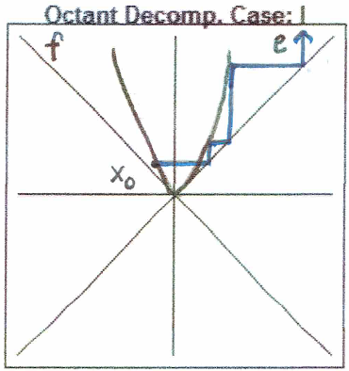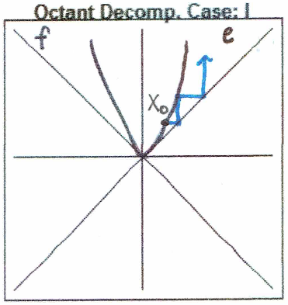

Case II: Region (f, d)

x0 lies in f: L1 > R1 > R2 > … -> p

x0 lies in d: R1 > R2 > R3 > … -> p

Orbit staircases into p.

Orbit about the fixed point is stable.

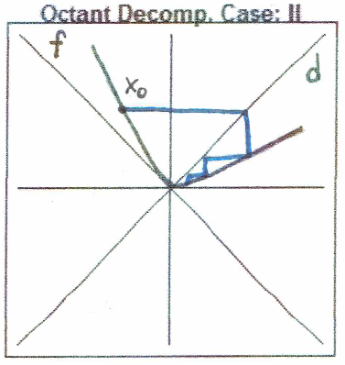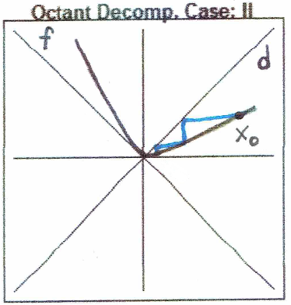

Case III: Region (f, b)

x0 lies in f: L1 < R1 < L2 < …

x0 lies in b: R1 < L1 < R2 < …

Orbit spirals out from p.

Orbit about the fixed point is unstable.

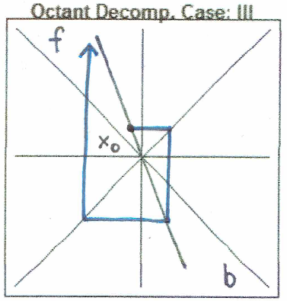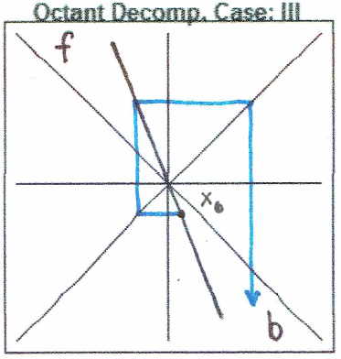

Case IV: Region (g, e)

x0 lies in g: L1 < R1 < R2 < …

x0 lies in e: R1 < R2 < R3 < …

Orbit staircases out from p.

Orbit about the fixed point is unstable.

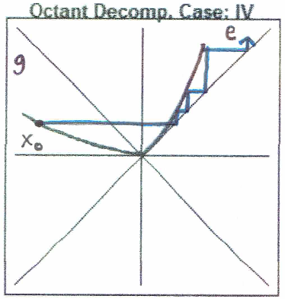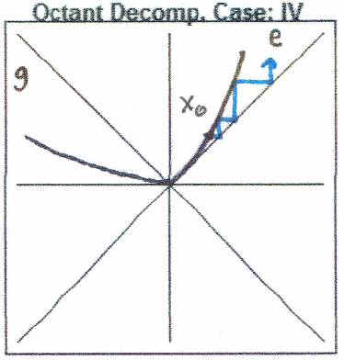

Case V: Region (g, d)

x0 lies in g: L1 > R1 > R2 > … -> p

x0 lies in d: R1 > R2 > R3 > … -> p

Orbit staircases into p.

Orbit about the fixed point is stable.

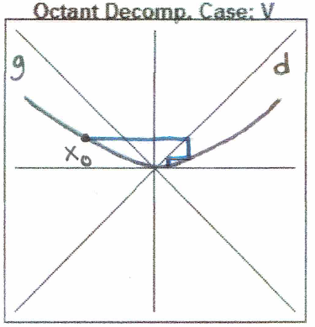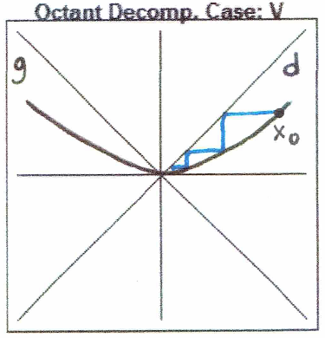

Case VI: Region (g, c)

x0 lies in g: L1 > R1 > L2 > … -> p

x0 lies in c: R1 > L1 > R2 > … -> p

Orbit staircases into p.

Orbit about the fixed point is stable.

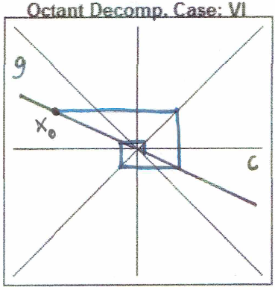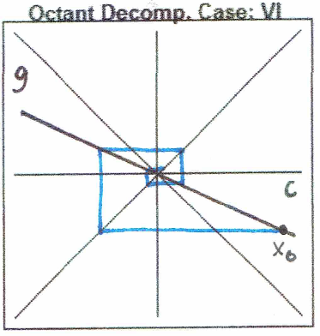

Case VII: Region (h, e)

x0 lies in h: L1 > L2 > L3 > … -> p

Orbit staircases into p

x0 lies in e: R1 < R2 < R3 < …

Orbit staircases out from p.

Orbit about the fixed point is not stable.

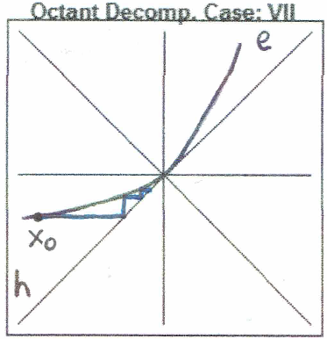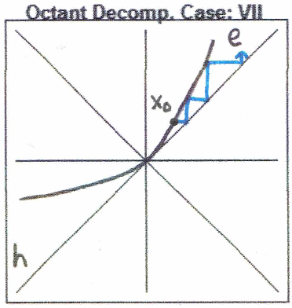

Case VIII: Region (h, d)

x0 lies in h: L1 > L2 > L3 > … -> p

x0 lies in d: R1 > R2 > R3 > … -> p

Orbit staircases into p.

Orbit about the fixed point is stable.

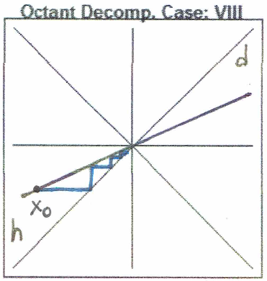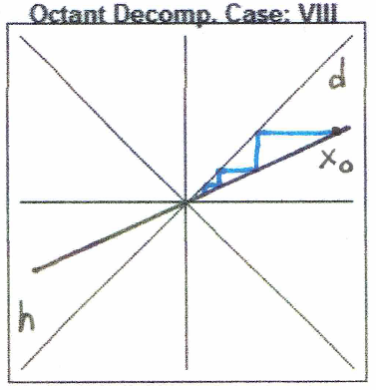

Case IX: Region (h, c)

x0 lies in h: L1 > L2 > L3 > … -> p

x0 lies in c: R1 > L1 > L2 > … -> p

Orbit staircases into p.

Orbit about the fixed point is stable.

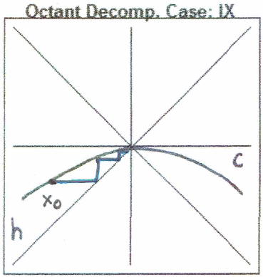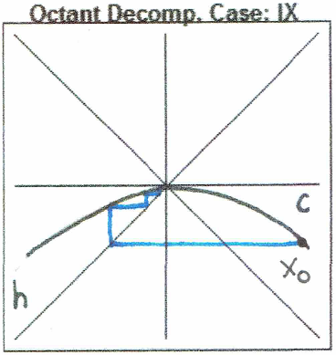

Case X: Region (h, b)

x0 lies in h: L1 > L2 > L3 > … -> p

x0 lies in b: R1 > L1 > L2 > … -> p

Orbit staircases into p.

Orbit about the fixed point is stable.

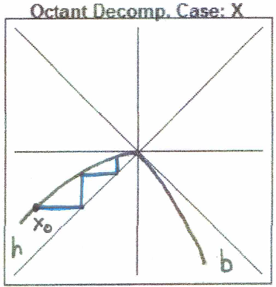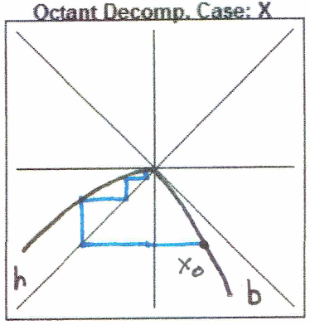

Case XI: Region (a, e)

x0 lies in a: L1 < L2 < L3 < …

x0 lies in e: R1 < R2 < R3 < …

Orbit staircases out from p.

Orbit about the fixed point is unstable.

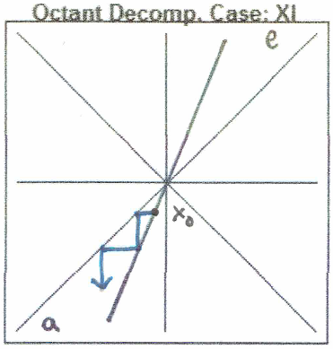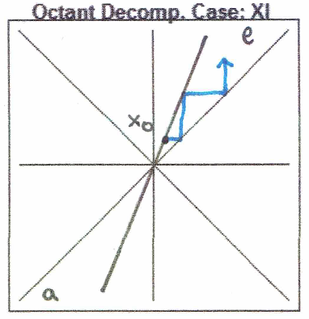

Case XII: Region (a, d)

x0 lies in a: L1 < L2 < L3 < …

Orbit staircases out from p

x0 lies in d: R1 > R2 > R3 > … -> p

Orbit staircases into p.

Orbit about the fixed point is not stable.

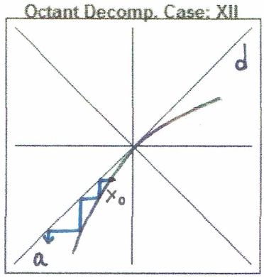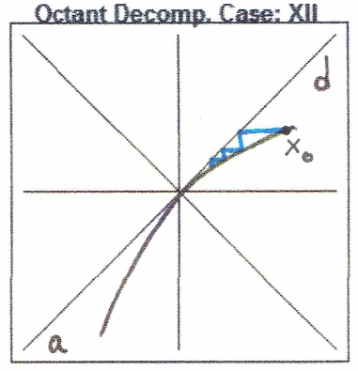

Case XIII: Region (a, c)

x0 lies in a: L1 < L2 < L3 < …

x0 lies in c: R1 < L1 < L2 < …

Orbit staircases out from p.

Orbit about the fixed point is unstable.

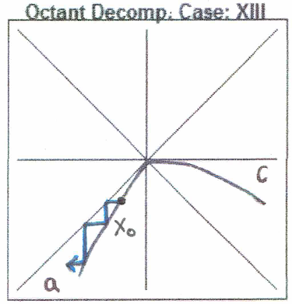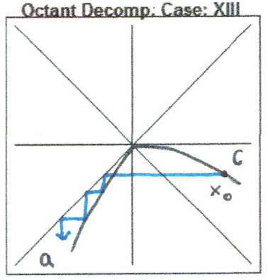

Case XIV: Region (a, b)

x0 lies in a: L1 < L2 < L3 < …

x0 lies in b: R1 < L1 < L2 < …

Orbit staircases out from p.

Orbit about the fixed point is unstable.

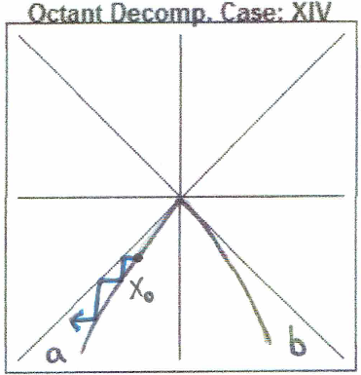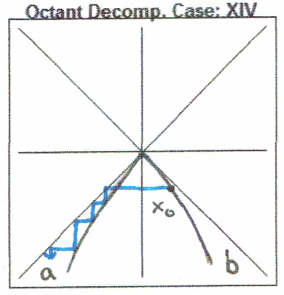

Note that, for regions adjacent to the diagonal line y = x (lie in the same quadrant as y = x), the orbit remains within the same region in its entirety. If a point in the orbit lies in a region adjacent to the antidiagonal y = -x (lie in the same quadrant as y = -x), the successive point in the orbit will lie in the other region that f lies in. It can be said that an orbit is “trapped” once it lies in a region adjacent to the diagonal.

Functions lying in regions:

{(f, c), (g, b)}

Orbital behavior is dependent on the function within these regions. The decomposition suggested below will allow us to then classify each of these cases unambiguously.

Octant decomposition is insufficient to unambiguously classify the remaining cases. Here, we will examine the possibility of classifying these regions unambiguously using further decomposition. We will use the lines y = -2x for regions (f, b) and y = -½x for regions (g, c) to further divide the sections. Let these new sections be denoted as fI, fII, gI, gII, bI, bII, cI, cII. Also, note that each of these regions are adjacent to the antidiagonal, meaning that the behavior of the orbit is dependent on a different region that of the region that the current iterate xi lies in. Let us call this the “Dodecagonal Decomposition”.

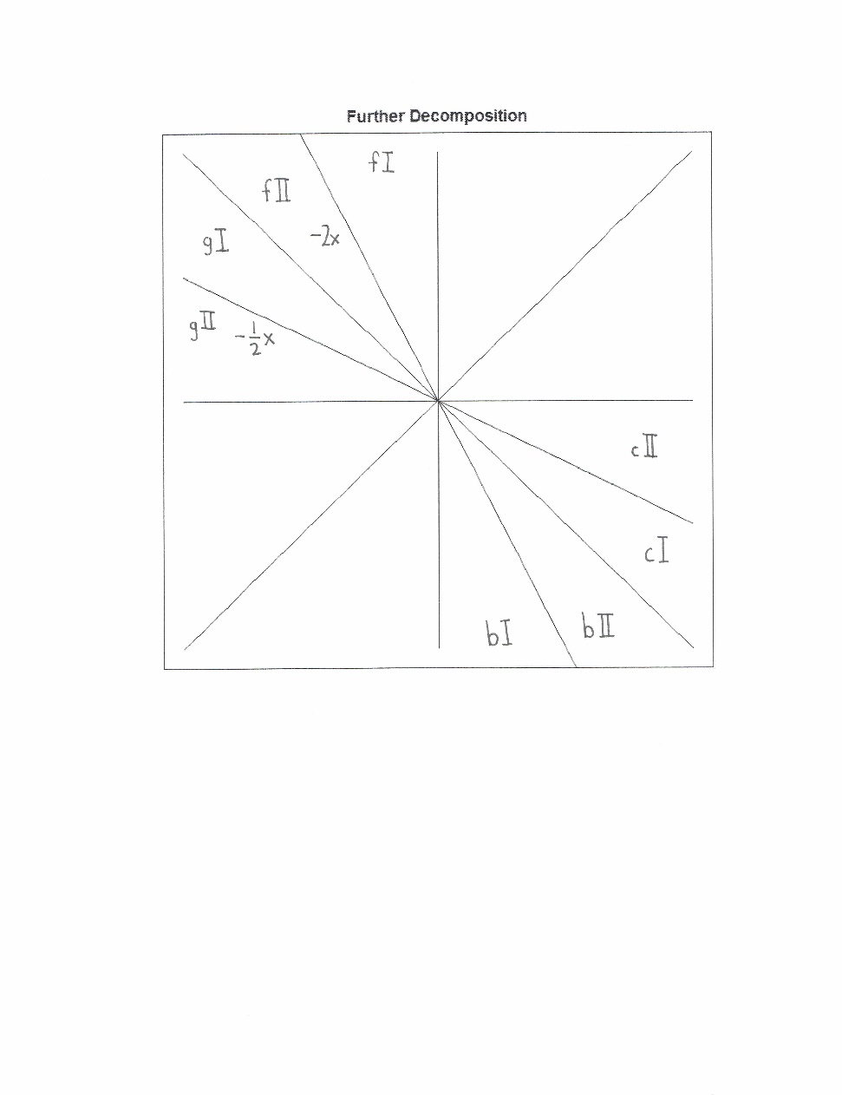

**Unambiguously Classified Cases Using Dodecagonal Decomposition**

fI : m < -2

fII: -2 < m < -1

gI: -1 < m < -1/2

gII: -1/2 < m < 0

bI: m < -2

bII: -2 < m < -1

cI: -1 < m < -1/2

cII: -1/2 < m < 0

Where again m, b are constants in y = mx + b such that the line intersects the fixed-point p.

Case I: Region (fI, cII)

L1 = R1 = L1 = …

Orbit stays a set distance away from p, neither

approaching nor moving away from p.

Orbit about the fixed point is not stable.

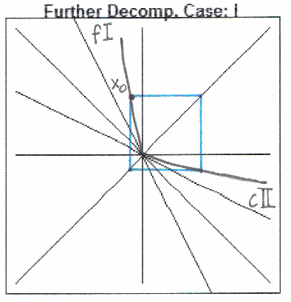

Case II: Region (fI, cI)

L1 < R1 < L2 < …

Orbit moves out from p.

Orbit about the fixed point is unstable.

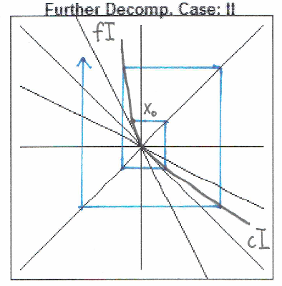

Case III: Region (fII, cII)

L1 > R1 > L2 > … -> p

Orbit moves into p.

Orbit about the fixed point is stable.

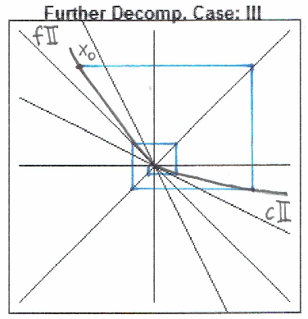

Case IV: Region (fII, cI)

L1 = R1 = L1 = …

Orbit stays a set distance away from p, neither

approaching nor moving away from p.

Orbit about the fixed point is not stable.

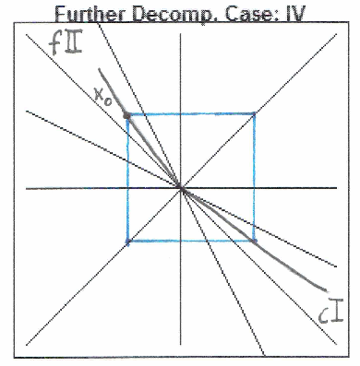

Case V: Region (gI, bII)

L1 = R1 = L1 = …

Orbit stays a set distance away from p, neither

approaching nor moving away from p.

Orbit about the fixed point is not stable.

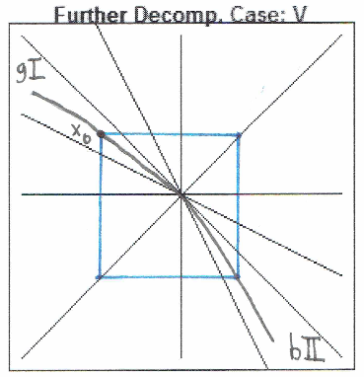

Case VI: Region (gI, bI)

L1 < R1 < L2 < …

Orbit moves out from p.

Orbit about the fixed point is unstable.

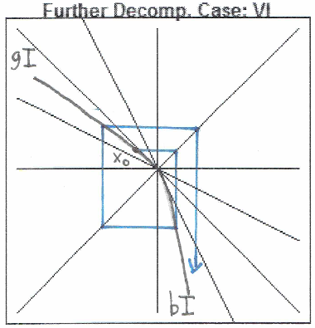

Case VII: Region (gII, bII)

L1 > R1 > L2 > … -> p

Orbit moves into p.

Orbit about the fixed point is stable.

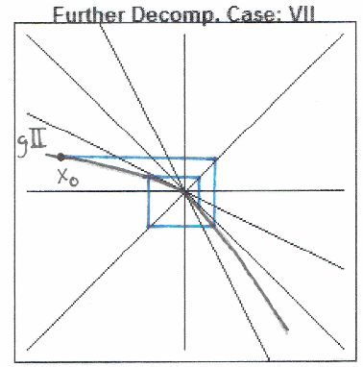

Case VIII: Region (gII, bI)

L1 = R1 = L1 = …

Orbit stays a set distance away from p, neither

approaching nor moving away from p.

Orbit about the fixed point is not stable.  
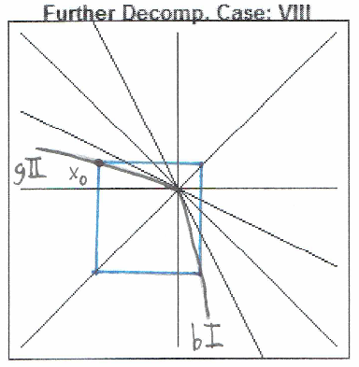

As can be seen, with dodecagonal decomposition, we may unambiguously classify the orbit about a fixed-point p for functions that lie in the regions f, g, b, and c. This yields a total of 22 unique cases for the orbit about a fixed-point for an arbitrary function.

Graphical iteration proves to be a convenient tool for problems too complex to solve analytically. Having unambiguous classifications encompassing all possible functions allows us to solve a wide range of problems pertaining to orbital behavior given that a generalized solution for any problem is available.